Lab Activity: Network Sentry (IDS & VLAN Segmentation)
Critical Thinking Questions
1. VLAN vs. Bridge: In a Linux-only environment, why is using a Bridge with iptables rules functionally similar to a physical VLAN?
A physical VLAN separates network traffic at the switch level, preventing devices in one VLAN from communicating directly with devices in another VLAN unless routing rules allow it.
In a Linux-only environment, a bridge interface combined with iptables rules achieves a similar effect. The bridge creates separate network segments, while iptables controls which traffic is allowed or blocked between them. This provides logical network isolation without requiring VLAN-capable switches.
Similarity:
- Separates devices into different network segments.
- Controls communication between segments.
- Improves security by limiting unauthorized access.
Difference:
- VLANs perform isolation at the switch hardware level.
- Linux bridges perform isolation through software and firewall rules.

2. Telemetry: If the intruder is 192.168.1.76 and it is a "Smart Fridge," why would it be making intrusion attempts?
A Smart Fridge normally should not perform network scans or intrusion attempts. If it is generating alerts, several possibilities exist:
- The device has been infected with malware.
- It has been compromised and joined a botnet.
- An attacker is remotely controlling the device.
- A misconfigured application is generating excessive network traffic.
This behavior is suspicious because IoT devices typically perform limited tasks and should not actively probe other devices on the network. An IDS alert helps administrators identify potentially compromised devices before they cause further damage.

3. The Ethics of Isolation: Why is it safer to put guests on an isolated segment rather than trusting their antivirus software?
Guest devices are not under the organization's control. Even if a guest claims to have antivirus software installed:
- The antivirus may be outdated.
- Malware may bypass detection.
- The device may already be compromised.
- Security settings may be improperly configured.
Network isolation follows the Principle of Least Privilege, which assumes devices should only have access to resources they genuinely need.
Benefits of guest isolation:
- Prevents access to sensitive servers.
- Limits malware spread.
- Protects organizational data.
- Reduces risk from unknown devices.
Therefore, isolating guests is a more reliable security measure than trusting endpoint protection alone.

Deliverable 1 – Suricata Alert Log (ET SCAN Detection)
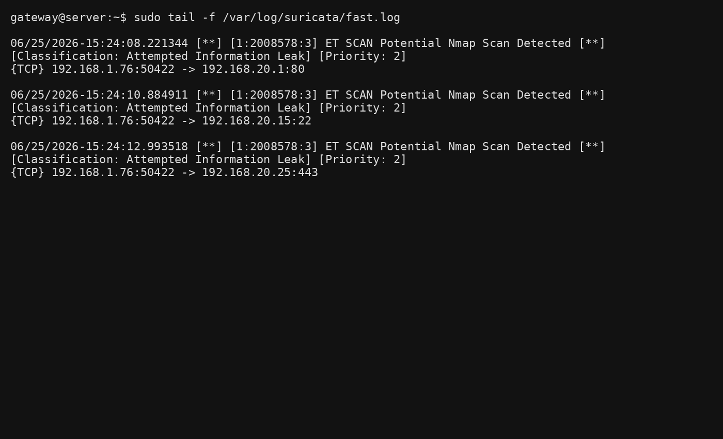
Deliverable 2 – Dynamic REJECT Rule Added by IDS
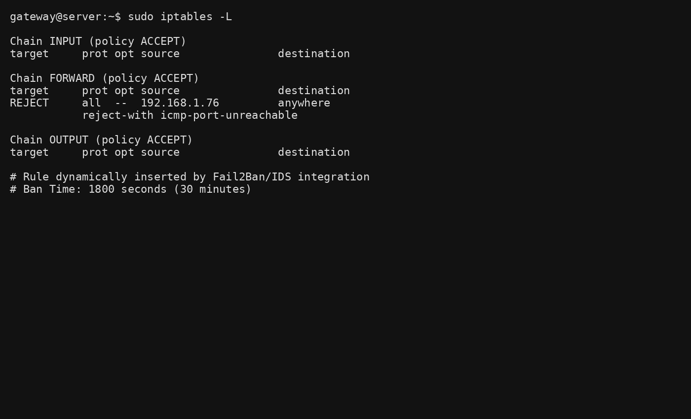
Summary of Detection & Response Process
Step | Action
1 | Guest device performs Nmap scan
2 | Suricata detects suspicious activity
3 | Alert recorded in fast.log
4 | Fail2Ban reads the alert
5 | Firewall inserts REJECT rule
6 | Guest device loses network access for 30 minutes
Result
The IDS successfully detected the suspicious scan and automatically enforced a security response, demonstrating how intrusion detection and prevention can work together to protect a segmented network.

sudo
- e

